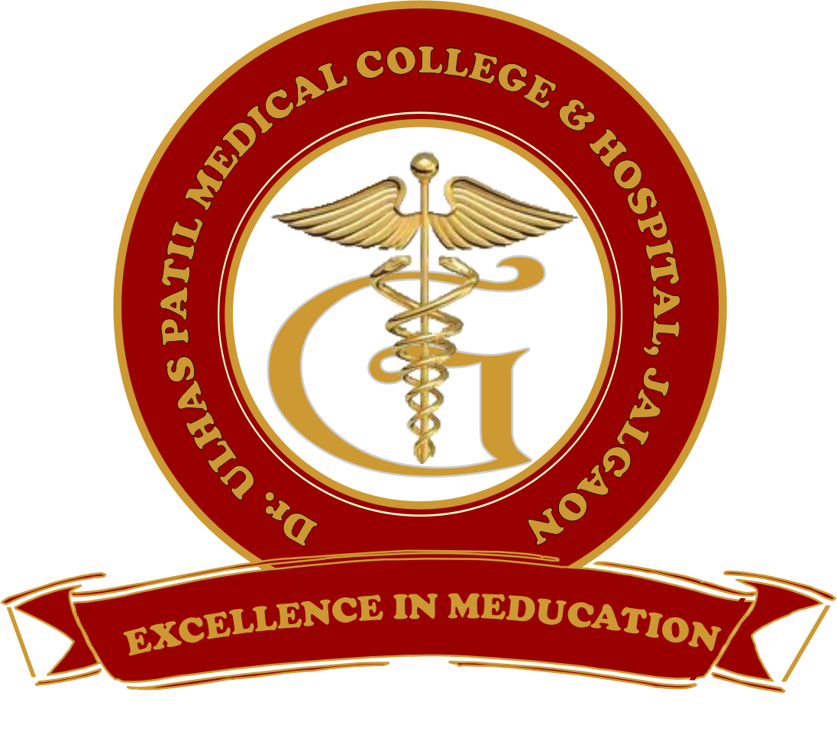 | Godavari Foundation’s  DR. ULHAS PATIL MEDICAL COLLEGE & HOSPITAL,  Recognized by Medical Council of India, Approved by Central Govt. of India, New Delhi,  Letter no. MCI-34(41)/2012-med./158127, dated 05/02/2013  Affiliated to Maharashtra University of Health Sciences, Nashik [College Code-1306]  Jalgaon-Bhusawal Road, Jalgaon Kh, Tal. & Dist. Jalgaon 425309  Tel. No. (0257)2366657, 2366678 Fax No. 0257-2366648  Email ID : dupmcj@yahoo.in Web Site : www.dupmc.ac.in
7.1.4 - Biomedical waste
Dr. Ulhas Patil Medical College Jalgaon has designed methods for the management of waste generated in the campus using the basic waste management strategy
The waste generated is classified into the following types:
- Solid waste Management
Solid waste includes both biodegradable and non-biodegradable components. The non –biodegradable solid waste generated in the campus include, paper, plastics, metal cans etc. Biodegradable waste includes food waste, vegetable peels, leaves etc.

'Use and throw' items like plastic cups, plates etc. used in the college canteen are replaced by reusable items steel glasses and plates. Regular collection of plastic cups, plastic bottles, Glass, paper and metal waste is done and sold for recyclers.
Food waste and non-biodegradable waste are collected in separate bins. Biodegradable waste is disposed off in three dumping yards of size 3m x 3m x 2m and especially food waste routed to biogas plant for generation of electricity and etc.

2. Liquid waste Management
Liquid waste that is generated in the institute falls into two following categories.

- Septic tank effluents from various sanitary blocks, water used for washing and cleaning of utensils etc. from canteen. Wastewater from laboratories: waste water generated from the laboratories is very small in quantity: hence they are handled along with septic sewage after specific treatment.

- As the college is located in rural un-sewered area, waste water generated from the sanitary facilities is disposed off into septic tanks located at different places in the campus and their effluents combined with canteen waste water is routed to own sewage treatment plant and then reuse for used for gardening, watering trees etc.

3. Biomedical waste management
Definition: Biomedical waste maybe defined as any solid, fluid or liquid waste material generated during short term and long-term care consisting of observational, diagnostic, therapeutic and rehabilitative services for a patients
3.1 Treatment and management of Biomedical waste
- Proper segregation and collection of biomedical waste from all patient care areas of the hospital should be implemented and monitored. Use appropriate PPE when segregating, packing, transporting, and storing biomedical waste.
- Biomedical waste should be transported in a closed container.
- Human anatomical waste, soiled waste, all hospital waste Microbiology, biotechnology and other clinical laboratory waste should collect in yellow colored non chlorinated plastic bag. Contaminated Waste (Recyclable) should collect in red colored non chlorinated plastic bags or containers. Waste Sharps including metals should collect in Puncture proof, leak-proof, tamper-proof containers. Glass ware should collect in Cardboard boxes with blue colored marking
- The biomedical waste of a hospital outsourced to an authorized contractor for the management and handling of biomedical waste as per rules designated by the State Pollution Control Board.

Dean Chairman
Dr Ulhas Patil Medical College, Jalgaon. Dr Ulhas Patil Medical College, Jalgaon.

